SOURCE CODE :

create database student;

use student;

DROP TABLE studentinfo;

CREATE TABLE studentinfo(

s_id int PRIMARY KEY,

s_fname varchar(15) NOT NULL,

s_mname varchar(15),

s_lname varchar(15),

s_address varchar(15),

s_city varchar(15) default 'Kathmandu',

s_age int CHECK (s_age>18),

s_phonenumber bigint UNIQUE

);

Insert INTO studentinfo(s_id,s_fname,s_mname,s_lname) VALUES('29',NULL,'Thapa','Magar');

Insert INTO studentinfo(s_id,s_fname,s_mname,s_lname) VALUES('29','Deepak','Thapa','Magar');

Insert INTO studentinfo(s_id,s_fname,s_lname,s_phonenumber) VALUES('29','Deepak','Thapa',9827131841),('11','Ayush','Lamsal',9827131841);

Insert INTO studentinfo(s_id,s_fname,s_lname,s_phonenumber) VALUES('29','Deepak','Thapa',9827131841),('11','Ayush','Lamsal',9827131842);

Insert INTO studentinfo(s_id,s_fname,s_lname,s_age,s_phonenumber) VALUES('11','Ayush','Lamsal',17,9827131840);

Insert INTO studentinfo(s_id,s_fname,s_lname,s_age,s_phonenumber) VALUES('11','Ayush','Lamsal',21,9827131840);

Insert INTO studentinfo(s_id,s_fname,s_lname,s_phonenumber) VALUES('29','Deepak','Thapa',9827131841),('11','Ayush','Lamsal',9827131840);

Insert INTO studentinfo(s_id,s_fname,s_lname,s_city,s_phonenumber) VALUES('29','Deepak','Thapa','Damauli',9827131841),('11','Ayush','Lamsal','Kathmandu',9827131840);

Insert INTO studentinfo(s_id,s_fname,s_lname,s_city,s_phonenumber) VALUES('11','Ayush','Lamsal',NULL,9827131840);

Insert INTO studentinfo(s_id,s_fname,s_lname,s_phonenumber) VALUES('29','Deepak','Thapa',9827131841),('11','Ayush','Lamsal',9827131840);

Insert INTO studentinfo(s_id,s_fname,s_lname,s_phonenumber) VALUES('29','Deepak','Thapa',9827131841),('29','Ayush','Lamsal',9827131840);

Insert INTO studentinfo(s_id,s_fname,s_lname,s_phonenumber) VALUES('29','Deepak','Thapa',9827131841),(NULL,'Ayush','Lamsal',9827131840);

Insert INTO studentinfo(s_fname,s_lname,s_phonenumber) VALUES('Deepak','Thapa',9827131841),('Ayush','Lamsal',9827131840);

INSERT INTO studentinfo(s_id,s_fname,s_mname,s_lname,s_phonenumber,s_age,s_address) VALUES('29','Deepak','Thapa','Magar',9827131841,22,'Damauli');

INSERT INTO studentinfo(s_id,s_fname,s_mname,s_lname,s_phonenumber,s_age,s_address) VALUES('11','Ayush',NULL,'Lamsal',9827131842,23,'Kalimati');

INSERT INTO studentinfo(s_id,s_fname,s_mname,s_lname,s_phonenumber,s_age,s_address) VALUES('12','Adarsh',NULL,'Acharya',9827131843,23,'Omae');

INSERT INTO studentinfo(s_id,s_fname,s_mname,s_lname,s_phonenumber,s_age,s_address) VALUES('13','Abiral',NULL,'Paudel',9827131844,23,'Wa');

INSERT INTO studentinfo(s_id,s_fname,s_mname,s_lname,s_phonenumber,s_age,s_address) VALUES('14','Abhiyan',NULL,'Poudel',9827131845,23,'Mou');

INSERT INTO studentinfo(s_id,s_fname,s_mname,s_lname,s_phonenumber,s_age,s_address) VALUES('15','Abhiyani',NULL,'Poudel',9827131846,23,'Shinderu');

INSERT INTO studentinfo(s_id,s_fname,s_mname,s_lname,s_phonenumber,s_age,s_address) VALUES('16','Abhiyaan',NULL,'Poudel',9827131847,23,'Baka');

INSERT INTO studentinfo(s_id,s_fname,s_mname,s_lname,s_phonenumber,s_age,s_address) VALUES('17','Abhiyano',NULL,'Poudel',9827131848,23,'Koros');

truncate table studentinfo;

SELECT * FROM studentinfo;

DROP TABLE phonedetails;

CREATE TABLE phonedetails(

s_phonenumber bigint,

sim_type varchar(10),

balance int,

s_id int FOREIGN KEY REFERENCES studentinfo(s_id)

ON DELETE CASCADE

ON UPDATE SET NULL

);

Insert into phonedetails values (9827131841,'ncell',100,29);

Insert into phonedetails values (9827131842,'ntc',100,11);

Insert into phonedetails values (9827131843,'ncell',100,12);

Insert into phonedetails values (9827131844,'ntc',100,13);

Insert into phonedetails values (9827131845,'ncell',100,14);

INSERT INTO studentinfo(s_id,s_fname,s_mname,s_lname,s_phonenumber,s_age,s_address) VALUES('10','Dipak','Thapa','Magar',9827131840,22,'Damauli');

Insert into phonedetails values (9827131846,'ntc',100,1000);

Insert into phonedetails values (9827131846,'ntc',100,15);

delete from studentinfo where s_id = 29;

delete from studentinfo where s_id = 17;

delete from phonedetails where s_id = 29;

update studentinfo set s_id = 10 where s_id = 11;

update studentinfo set s_id = 10 where s_id = 15;

update phonedetails set s_id = 1000 where s_id = 29;

update phonedetails set s_id = 10 where s_id = 29;

truncate table phonedetails;

SELECT * FROM studentinfo;

SELECT * FROM phonedetails;

OUTPUT

1. NOT NULL



Error message displays when trying to insert NULL into ‘FName’

An error occurs while inserting data into the table without specifying a value for the 'FName' column



Working when FName has a value.

1. UNIQUE



Displays an error message when trying to insert same values in Phone

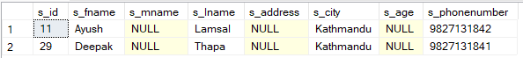

Works properly when Phone is different for each entry

1. CHECK

Age column is added and it has to be checked to ensure each entry is above 18.



Error message is displayed when ages 18 or below are inserted.



It works when all individuals have ages above 18

1. DEFAULT

The default value of PAddress is set to ‘Kathmandu’

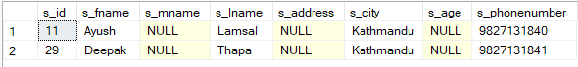

All city value is set to default = ‘Kathmandu’



When city value is inserted, default value isn’t displayed.



If NULL is inserted in city value, NULL is displayed instead of the default value.

1. PRIMARY KEY

ID is set as the primary key.



Error message when trying to set a common primary key in two insertions.



Error message when trying to enter NULL into primary key.

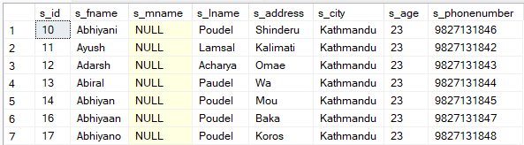

Working when primary key is unique for each insertion.

1. For multi-valued attribute such as Phone, a different table was created and linked with the help of ID as foreign key in child table(PD).

INSERTION IN PARENT TABLE CAUSES NO ISSSUES

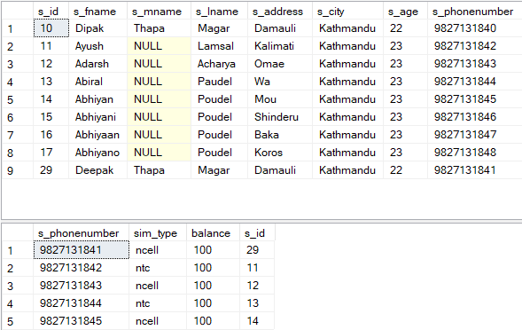

New value inserted into studentinfo

INSERTION IN CHILD TABLE MAY CAUSE ISSUES



Error message when trying to insert a data into child table with an ID that does not exist in the parent table.

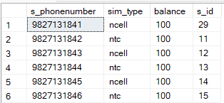

Working when trying to insert a new data into child table that is linked to an id in the parent table.

1. DELETION IN PARENT TABLE MAY CAUSE ISSUES



Error message when trying to delete a linked entry in the parent table

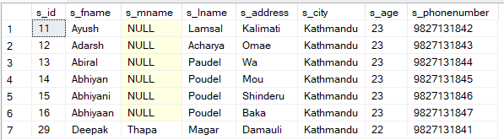

Working when trying to delete an insert in the parent table that was not linked in the child table.

1. DELETION IN CHILD TABLE CAUSES NO ISSUES

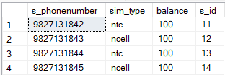

Deleting entry linked to ID 2 in the child table.

1. UPDATING IN PARENT TABLE MAY CAUSE ISSUES



Error message when trying to update id that is linked to child table.

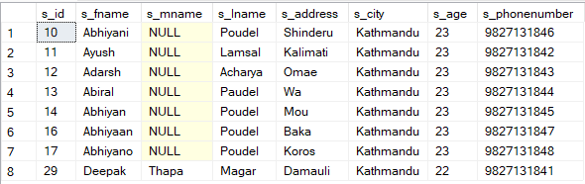

Working when updating values that are not linked in parent table such as id=15 to 10.

1. UPDATING IN CHILD TABLE MAY CAUSE ISSUES



Error message when trying to update linked foreign key with 1000

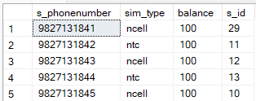

Working when trying to update other values in child table.

1. ON DELETE CASCADE

It resolves the issue of deleting linked entries in the parent table by automatically removing corresponding rows in the child table when a parent row is deleted.



Allows deletion of linked entry in the parent table and also removes that entry from the child table.

1. ON UPDATE SET NULL

Allows updating of linked primary key in the parent table and sets that updated value as NULL in the child table.

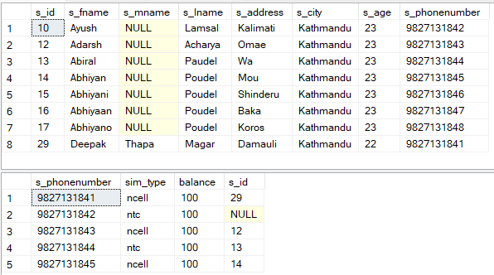

ID was updated from 11 to 10 in the parent table and its corresponding value in the child table is set to NULL.